Roadmap for IRI’s architecture:

Key Standards:
- Java and open standards
- Linux
- On Demand computing model (or Utility computing)
- Service-Oriented Architecture (Web services)
- Autonomic computing
- Grid computing
- Virtual computing

Impact Assessment:
- Impact on enterprise customer
- Impact on customers
- Impact on service provider
- Impact on Marketing Risks

Boundary Assessment:
- Scope - The scope must be defined very carefully, since it will include today's technologies and future technologies that service the same customer. The "utility" services model only works for services that have been identified and dedicated or load-balanced.
- Pricing - For pricing purposes, dedication and load balancing reflect different levels of resource allocation. Unlike the classic load balancing or resource sharing of traditional outsourcing, "utility" computing requires dedicated resources. The benefit of this is greater control and uptime. The customer pays the full cost. Consequently, "utility" outsourcing is not cost-driven, except to the extent that the service provider can buy (or make) the necessary infrastructure more cheaply than the customer can.
- Security - Security and integrity of all the data that is outsourced along with the business applications is a major concern for corporations. Especially when the same vendor is hosting competitors' systems.
- Reliability/Viability of the providers - The long term viability of the vendor will play a major role in who will get the most market share. Corporations do not want their outsourced businesses be abandoned by vendors who go under

On Demand Computing Model
On Demand computing is the on-demand delivery of infrastructure, applications and business processes in a security-rich, shared, scaleable and standards-based computer environment over the internet for a fee. Customers will tap into IT resources - and pay for them - as easily as they now get their electricity or water. On Demand computing is the logical extension of outsourcing. With corporations realizing unimaginable cost savings and agility with outsourcing, it is very unlikely that they will resist migrating to on demand computing.

Elements of e-business on demand (taken from IBM’s model)

- Infrastructure on demand is the underlying platform - a shared, scalable computing environment made up of both core services and management services.
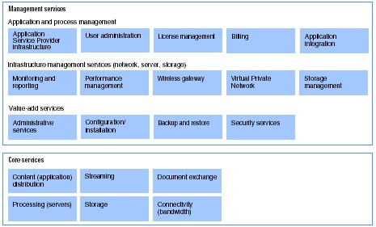
- Business process on demand enables enterprises to quickly acquire and deploy e-business applications - as well as entire business processes - over the network on a pay-as-you-go basis.
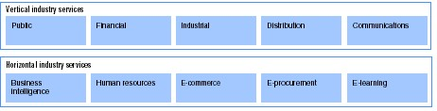
- Know-how includes consulting support from IBM and their globally-based Business Partners.

On Demand computing concept carries this three-fold promise:
- It will simplify IT, as in reducing or masking complexity
- It will turn IT from a fixed to a variable cost
- And it will cut the biggest cost culprit of all: operating expenses

Benefits
- Access new capabilities more quickly
- Improve service performance
- Reduce upfront investment
- Gain expertise not available internally
- Leverage best practices
- Improve economies of scale
- Meet unpredictable fluctuation in demand

Autonomic computing
End-to-end automation
Disaster recovery
Heterogeneous workload management
E2E system management
Virtual server hosting
E2E security

Service Oriented Architecture
- Service-Oriented Architectures (SOA). Enterprise solutions can be viewed as federations of services connected via well-specified contracts that define their service interfaces. The resulting system designs are frequently called Service Oriented Architectures (SOAs). Flexibility can be enhanced in a system’s architecture by organizing a system as a collection of encapsulated services making calls on operations defined through their service interfaces. Many organizations now express their solutions in terms of services and their interconnections.

Product Line development
- Software Product Lines. Frequently, there is a great deal of commonality among the systems an organization develops and maintains. We see recurring approaches at every level of an enterprise software project, from having standard domain models that capture core business processes and domain concepts, to the way in which developers implement specific solutions to realize designs in code. Organizations gain a great deal of efficiency when patterns can be defined by skilled practitioners and propagated across the IT organization. This represents a move toward a software product-line view of development that promotes planned reuse of assets, along with an increasing level of automation, to realize solutions for large parts of the systems being developed. More generally, we can understand the application of well-defined patterns in a product-line view of development as a way to transform descriptions of a solution from one level of abstraction to a lower level of abstraction.

Grid Computing
Applications fall into 3 categories:
- Just-in-Time, or On-demand computing: On-demand computing provides access to specialized resources that are only needed on a short-term or infrequent basis. When such a resource is requested, it is usually needed immediately. However, because access needs are sparse, there might not be sufficient justification to own the resources or even co-locate users with the resources. In a grid environment, many users might share such resources cost-effectively.

- Data-intensive computing: With the current explosion in information, data-intensive computing becomes an important application area that must be supported by grids, which involves the synthesis of new information from geographically distributed data sources. Distributed storage-area networks demands hardware or software support of a single I/O space and global file and database management not only in clusters but also in pervasive information grids.

- Collaborative computing: The newest application enabled by computational grids is collaborative computing, or the creation of laboratories without walls. The basic goal is to enhance the interactions between humans and computing resources that might be geographically distributed. There are many issues involved in dealing with the real-time requirements human perceptual capabilities and the rich variety of interactions that might take place with the computational resources.

Virtual computing
Availability
Provisioning
Virtualization
Grid
Storage Management
Systems Management
Applications Management
Performance, Quality of Service
Utility Computing
Policy Automation
Services and Support

Model Driven

